**AIM:**

**DATE: 14-Feb-2021**

**Roll no.:18BCE186**

**Name: Prem Desai**

**Course: LAMP TECHNOLOGY**

**2CSDE69**

**Practical No.:02**

**(A) Write a PHP function that check whether numbers are an amicable number or not.**

**(B) Write a PHP function to check whether number is Automorphic Number or not.**

**(C) Write a PHP function that check whether user entered number is special number or not.**

**(D) Write a PHP function that check whether user entered number is Kaprekar number or not. (Extra)**

**Methodology followed:**

**(A)**

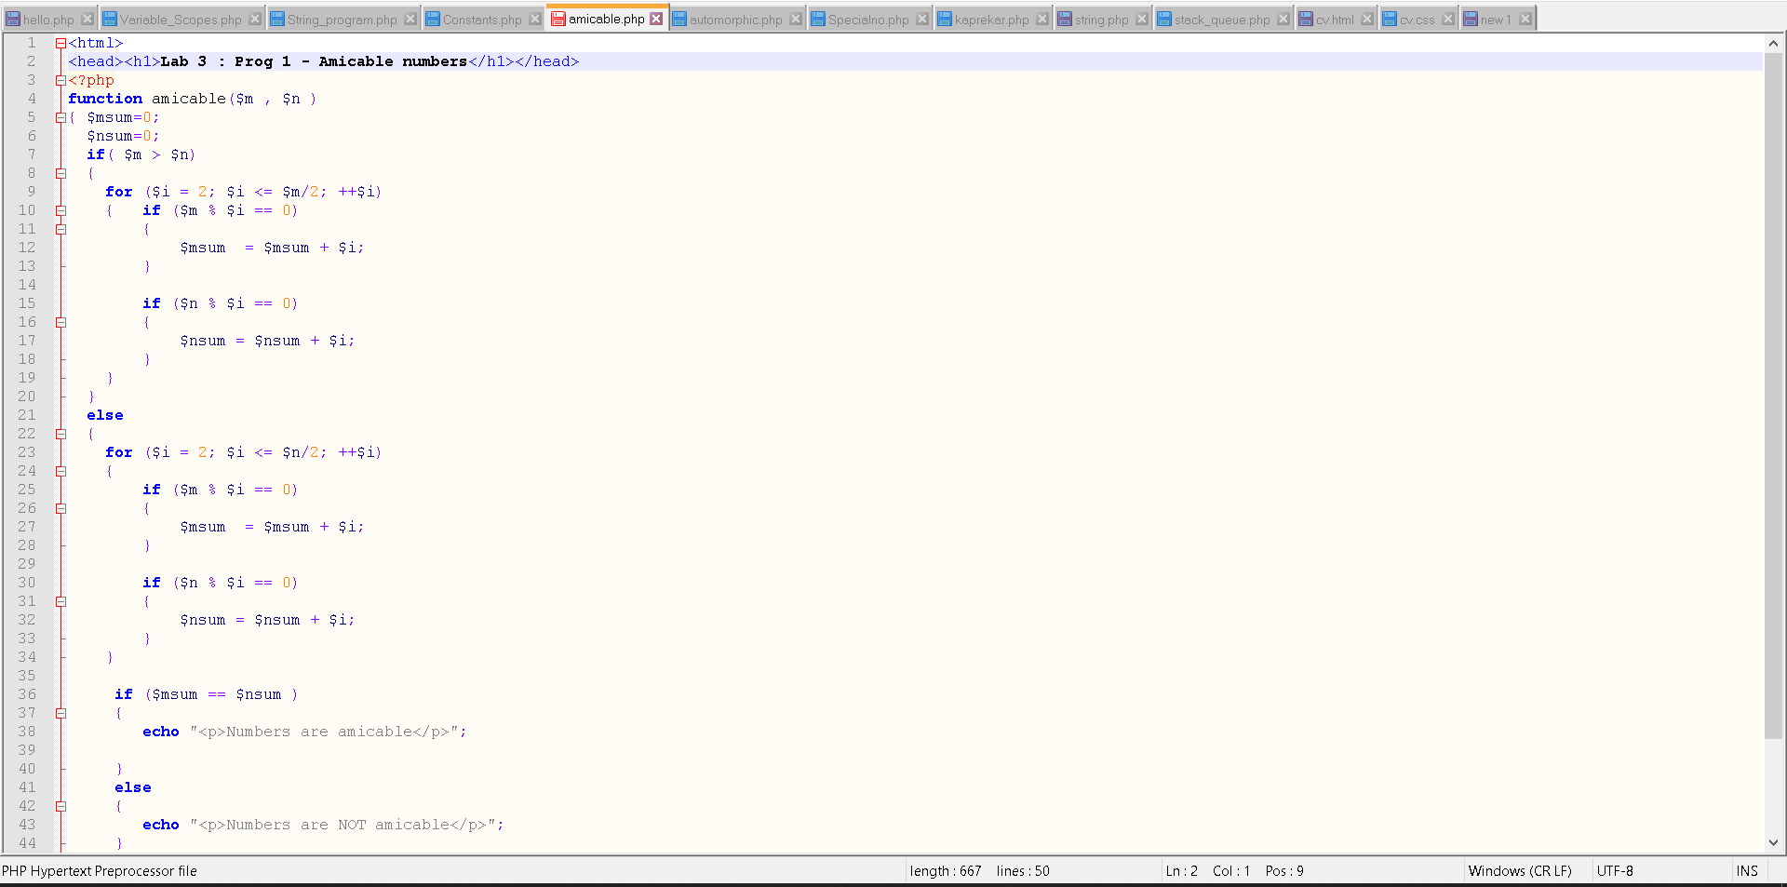

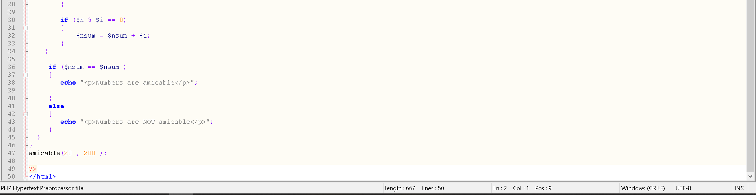

**(B)**

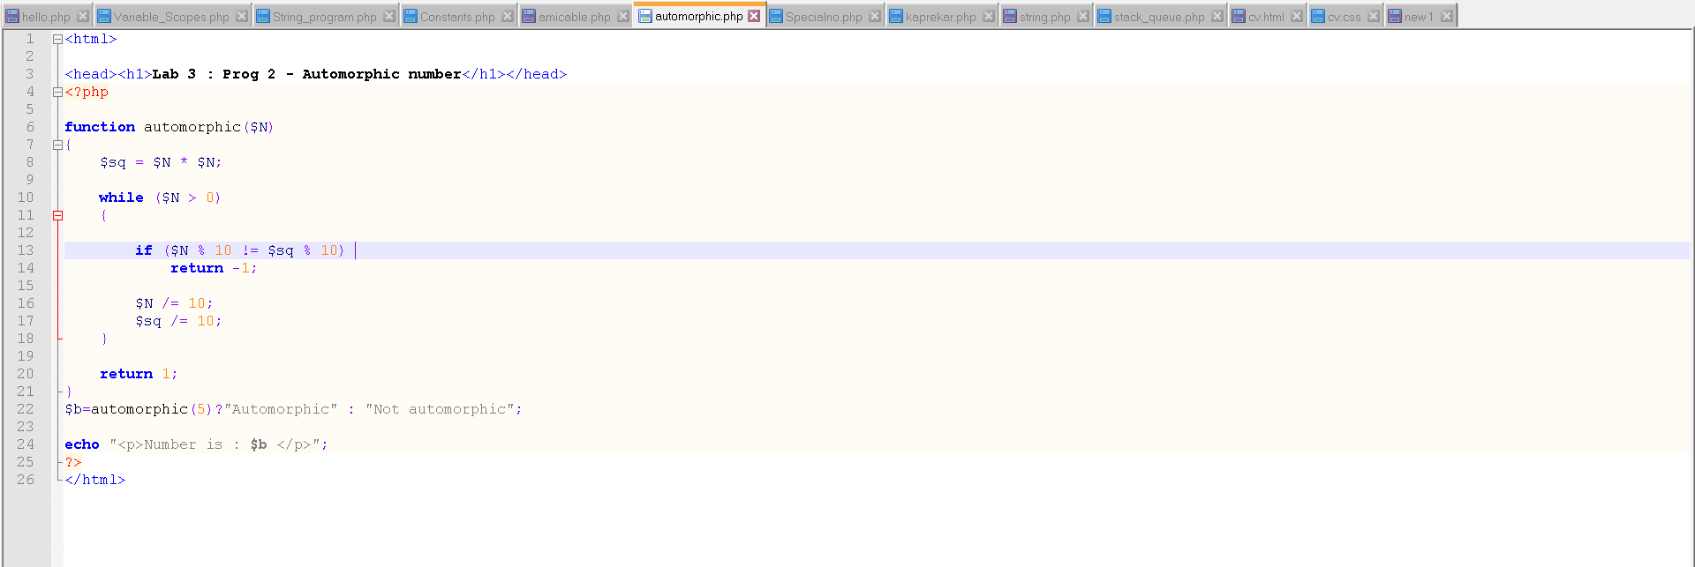

**(C)**

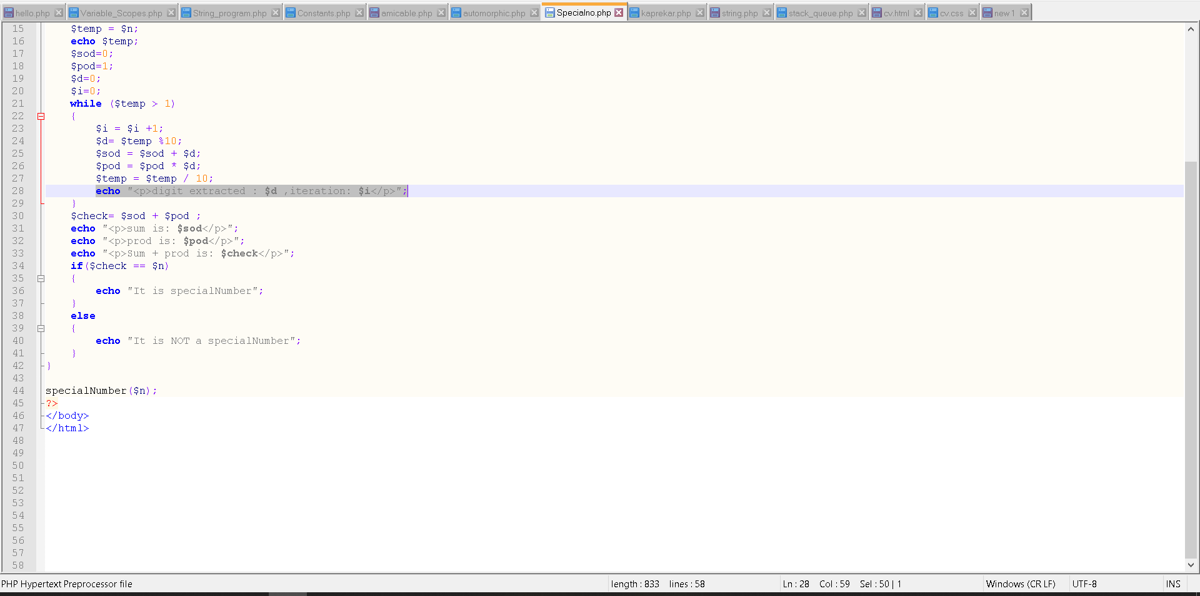

**(D)**

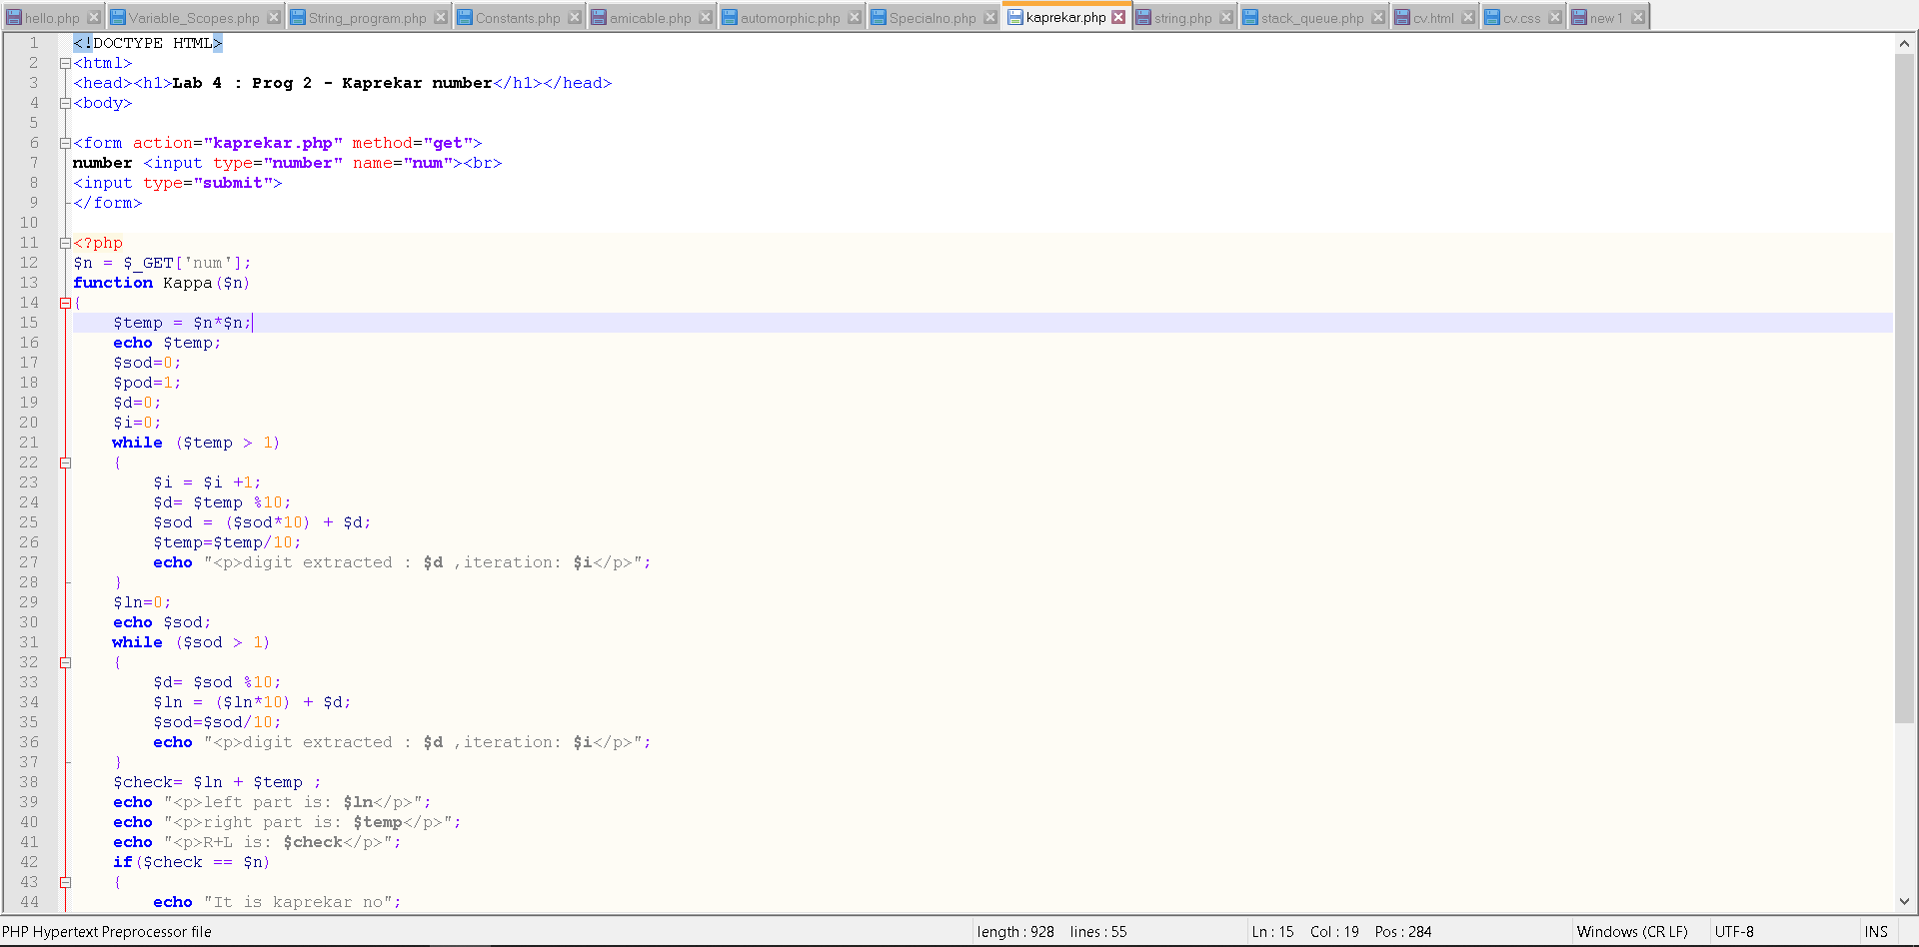

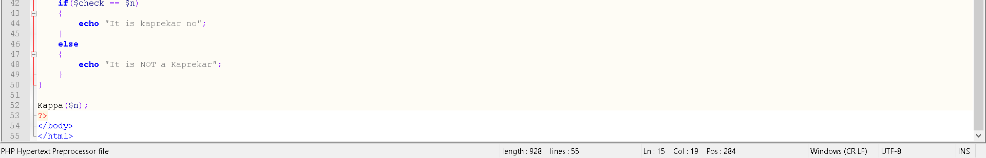

**Input:**

**(A) (20, 200)**

**Output:**

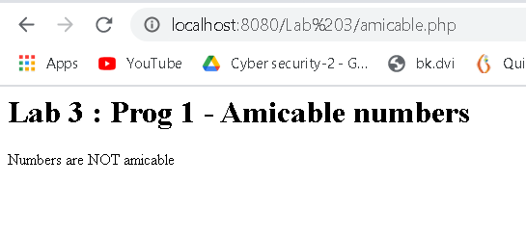

**Input:**

**(B) 5**

**Output:**

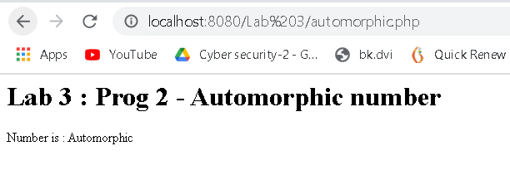

**Input:**

**(C) 59**

**Output:**

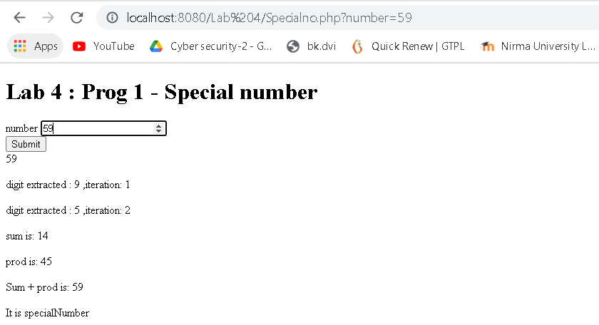

**Input:**

**(D)1**

**Output:**

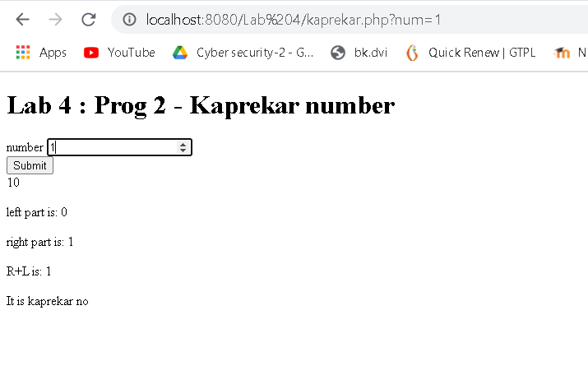

**Conclusion:**

**In this practical various type of input numbers were classified into whether they are amicable, automorphic, special, etc. or not.**

**Input was static for first two (A and B) and dynamic for the latter two (C and D). Hence different types of input options were also explored along with implementing given programs.**

**Signature of teacher:**